1. Title
Practical No. 1: Version Control Operations Using Git

2. Aim
Aim: To learn and perform version control operations using Git by creating a local repository, tracking file changes, managing commits, creating branches, merging branches, and viewing project history.
Tgi

3. Theory
Git is a distributed version control system developed by Linus Torvalds in 2005. It helps developers track changes in source code, collaborate with team members, maintain different versions of a project, and recover previous versions when needed.
Version control records every change made to files in a repository. Git stores these changes as snapshots called commits. Developers can work on separate branches, merge their work into the main project, and synchronize repositories using remote services like GitHub.

Advantages of Git
- Tracks change efficiently.
- Supports multiple developers working simultaneously.
- Allows rollback to previous versions.
- Maintains complete project history.
- Facilitates collaboration through branching and merging.
- Works offline because it is a distributed version control system.

4. Software Requirements
- Operating System: Windows 10/11, Linux, or macOS
- Software: Git
- Terminal: Command Prompt, PowerShell, Git Bash, or Terminal
- Optional: GitHub account

5. Commands Used
Create a table like this:
Sr. No. | Command | Purpose
1 | git --version | Displays installed Git version.
2 | git config --global user.name | Sets Git username.
3 | git config --global user.email | Sets Git email address.
4 | git config --list | Displays Git configuration.
5 | git init | Initializes a new Git repository.
6 | git status | Shows repository status.
7 | git add . | Stages all files.
8 | git commit -m "message" | Saves staged changes.
9 | git log | Displays commit history.
10 | git log --oneline | Displays compact commit history.
11 | git diff | Shows differences between file versions.
12 | git branch | Lists or creates branches.
13 | git switch feature | Switches to another branch.
14 | git merge feature | Merges a branch into the current branch.
15 | git mv | Renames a file.
16 | git rm | Deletes a tracked file.
17 | git ls-files | Lists tracked files.
18 | git reflog | Shows reference log.
19 | git show | Displays details of a commit.
20 | git remote -v | Lists remote repositories.
21 | git restore <file> | Discards local changes made to a file and restores it to the last committed version.
22 | Git stash
  Temporarily saves uncommitted changes without creating a commit.
23 | Git stash pop | Restores the most recently stashed changes and removes them from the stash list.
24 | Git branch -d
  Deletes a branch that has already been merged.
25 | git clone <repourl> | Creates copy

7. Output
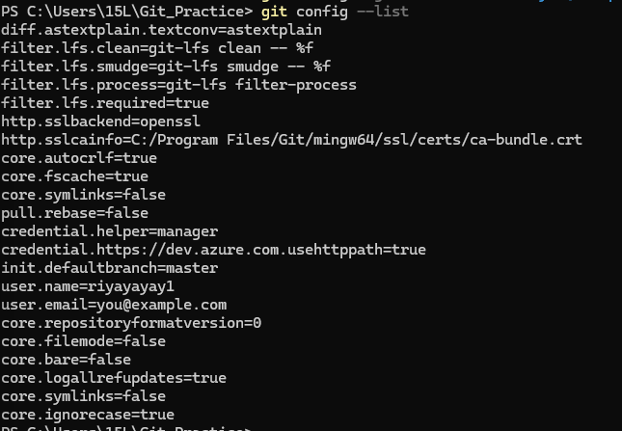
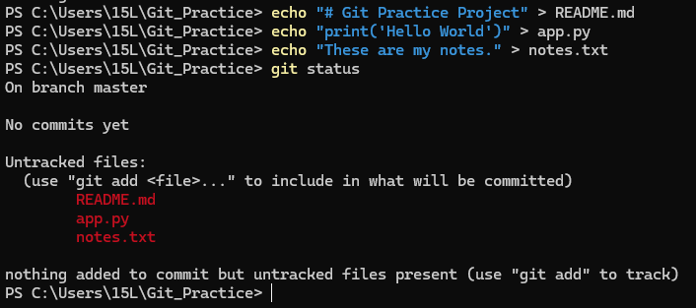
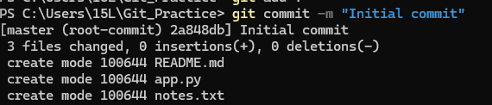
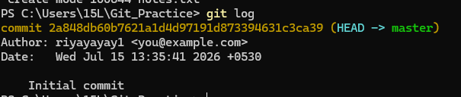
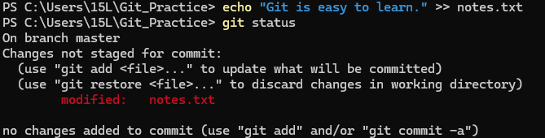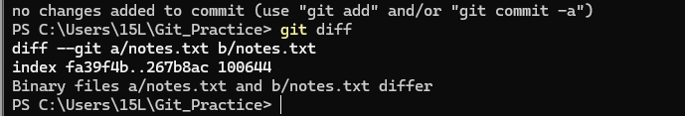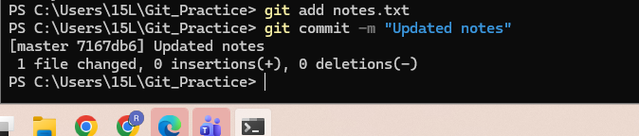
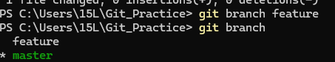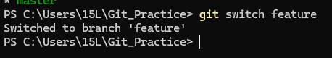
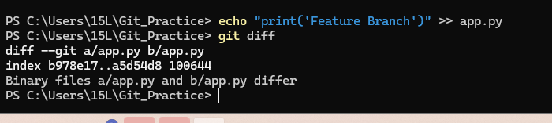
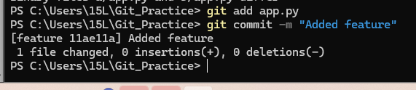
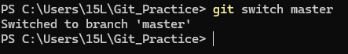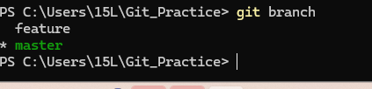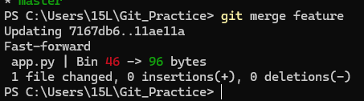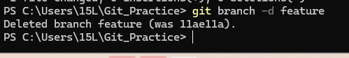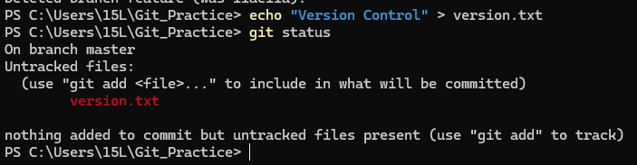

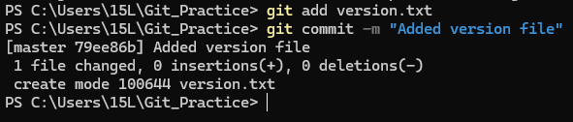

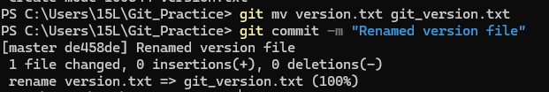

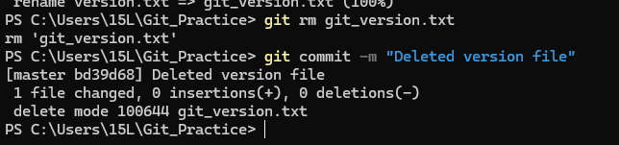
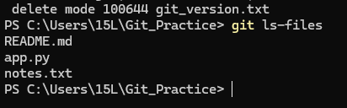
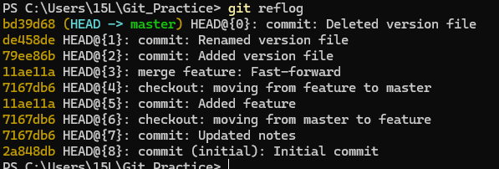

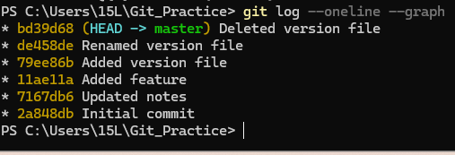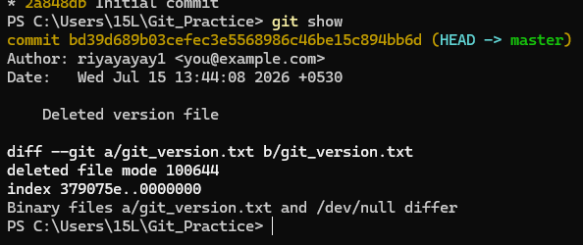

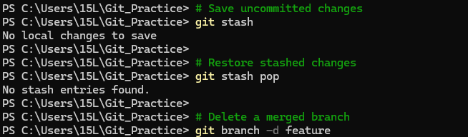

8. Result
Successfully performed version control operations using Git, including repository creation, file tracking, commits, branching, merging, and history management.

9. Conclusion
Through this practice , I learned how to use Git as a version control system to manage project files efficiently. I learned to initialize a Git repository, configure Git, track file changes, stage and commit updates, view commit history, create and switch branches, merge branches, rename and delete tracked files, and restore previous versions when needed. I also understood how Git maintains project history and supports organized development, making it easier to collaborate and manage software projects.

